**PowerBI Report and Dashboard**

A **Power BI dashboard** is a single page, often called a canvas, that uses visualizations to tell a story. ... The visualizations on a **dashboard** come from **reports** and each **report** is based on one dataset. In fact, one way to think of a **dashboard** is as an entryway into the underlying **reports** and datasets.

**Dashboard**

Because it is limited to one page, a well-designed dashboard contains only the most-important elements of that story.

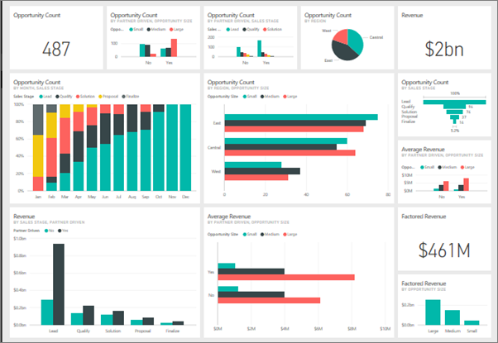

The visualizations you see on the dashboard are called tiles and are pinned to the dashboard by report designers. Selecting a tile takes you to the report page where the visualization was created.

Report

The visualizations on a dashboard come from reports and each report is based on one dataset. In fact, one way to think of a dashboard is as an entryway into the underlying reports and datasets. Selecting a visualization takes you to the report (and dataset) that was used to create it.

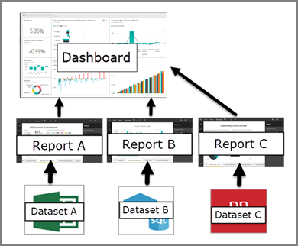

## What is a Power BI report?

A Power BI ***report*** is a multi-perspective view into a dataset, with visualizations that represent different findings and insights from that dataset. A report can have a single visualization or pages full of visualizations. Depending on your job role, you may be someone who creates reports and/or you may be someone who consumes or uses reports.

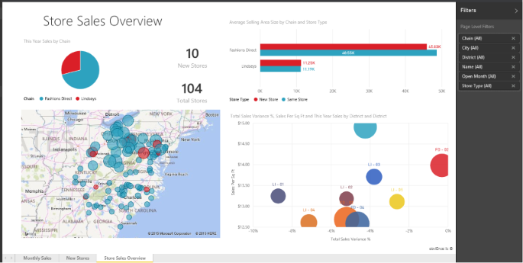

This report has 3 pages (or tabs) and we're currently viewing the Store Sales Overview page. On this page are 6 different visualizations and a page title. Visualizations can be pinned to dashboards and when that pinned visualization is selected, it opens the report it was pinned from.

## Advantages of dashboards

Dashboards are a wonderful way to monitor your business, to look for answers, and to see all of your most-important metrics at a glance. The visualizations on a dashboard may come from one underlying dataset or many, and from one underlying report or many. A dashboard can combine on-premises and cloud data, providing a consolidated view regardless of where the data lives.

A dashboard isn't just a pretty picture; it's highly interactive and highly customizable and the tiles update as the underlying data changes.

## Dashboards versus reports for Power BI *****consumers*****

| **Capability** | **Dashboards** | **Reports** |
| --- | --- | --- |
| Pages | One page | One or more pages |
| Data sources | One or more reports and one or more datasets per dashboard | A single dataset per report |
| Subscribe | Can subscribe to dashboard emails | Can subscribe to report page emails |
| Filtering | Can't filter or slice | Many different ways to filter, highlight, and slice |
| Set alerts | Can create alerts to email you when certain conditions are met | No |
| Featured | Can set one dashboard as your "featured" dashboard | Cannot create a featured report |
| Natural language queries | Available from dashboard | Not available from reports |
| Can see underlying dataset tables and fields | No. Can export data but can't see tables and fields in the dashboard itself. | Yes. Can see dataset tables and fields and values. |

Reports are often confused with dashboards since they too are canvases filled with visualizations. But there are some major differences from a Power BI consumers point of view.

# Featured dashboards

## Create a Featured dashboard

Many of us have one dashboard that we visit more than any others. It might be the dashboard we use to run our business, or it might be a dashboard that contains an aggregation of tiles from many different dashboards and reports.

set as featured icon

When you select a dashboard as featured, each time you open Power BI service, it will open with that dashboard displayed.

## Interacting with tiles on a dashboard

1. Hover over the tile to display the ellipses.

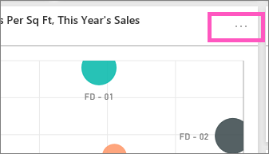

1. Select the ellipses to open the tile action menu. The options available vary by visual type and method used to create the tile. Here are a few examples of what you may see.
   * tile created using Q&A

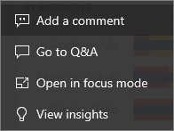

* + tile created from a workbook

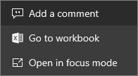

* + tile created from a report

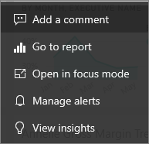

## How to use the Comments feature

Comments can be added to an entire dashboard or to individual visuals on a dashboard. Add a general comment or a comment targetted at specific colleagues.

### Add a general dashboard comment

1. Open a Power BI dashboard and select the **Comments** icon. This opens the Comments dialog.

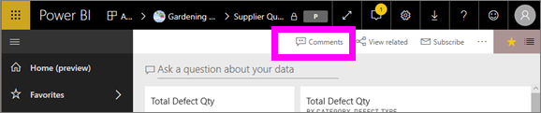

Here we see that the dashboard creator has already added a general comment. Anyone with access to this dashboard can see this comment.

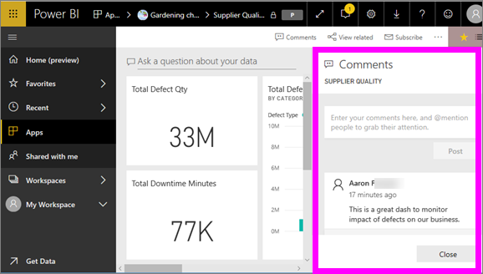

1. To respond, select **Reply**, type your response, and select **Post**.

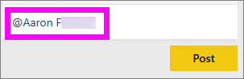

By default, Power BI directs your response to the colleague who started the comment thread, in this case Aaron F.

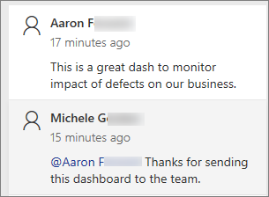

1. If you want to add a dashboard comment that is not part of an existing thread, enter your comment in the upper text field.

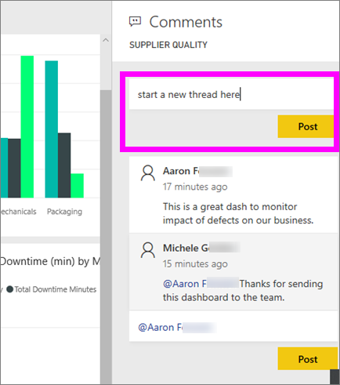

## List of visualizations available in Power BI

### Area charts: Basic (Layered) and Stacked

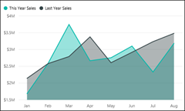

**Tip**

The Basic Area chart is based on the line chart with the area between the axis and line filled in.

### Bar and column charts

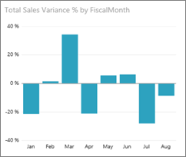

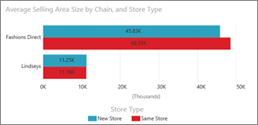

**Tip**

Bar charts are the standard for looking at a specific value across different categories.

### Cards: Multi row



### Cards: Single number

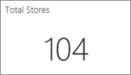

### Combo charts

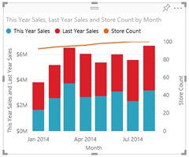

**Tip**

A Combo chart combines a column chart and a line chart. Choose from Line and Stacked Column and Line and Clustered Column.

### Doughnut charts

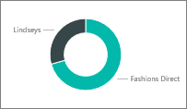

**Tip**

Doughnut charts are similar to Pie charts. They show the relationship of parts to a whole.

### Funnel charts

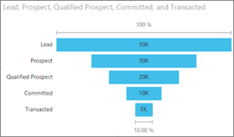

**Tip**

Funnels help visualize a process that has stages and items flow sequentially from one stage to the next. Use a funnel when there is a sequential flow between stages, such as a sales process that starts with leads and ends with purchase fulfillment.

### Gauge charts

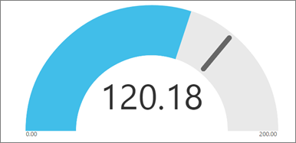

**Tip**

Displays current status in the context of a goal.

### KPIs

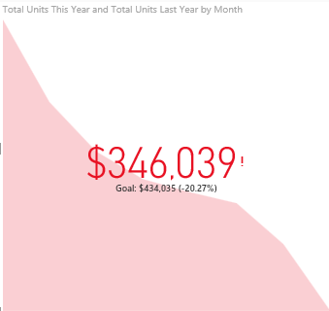

**Tip**

Displays progress toward a measurable goal.

### Line charts

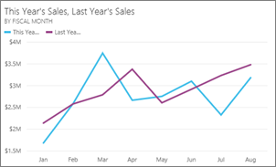

**Tip**

Emphasize the overall shape of an entire series of values, usually over time.

### Maps: Basic maps

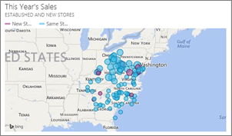

**Tip**

Used to associate both categorical and quantitative information with spatial locations.

### Maps: ArcGIS maps

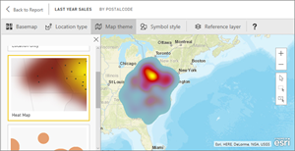

### Maps: Filled maps (Choropleth)

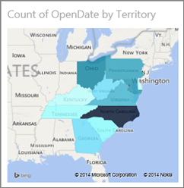

**Tip**

The more intense the color, the larger the value.

### Maps: Shape maps

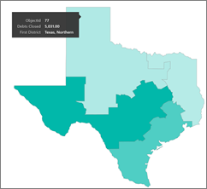

**Tip**

Compares regions by color.

### Matrix

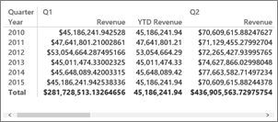

### Pie charts

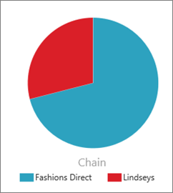

Pie charts show the relationship of parts to a whole.

### Ribbon chart

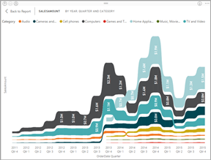

Ribbon charts show which data category has the highest rank (largest value). Ribbon charts are effective at showing rank change, with the highest range (value) always displayed on top for each time period.

### Scatter and Bubble charts

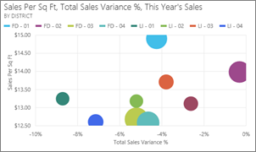

**Tip**

Display relationships between 2 (scatter) or 3 (bubble) quantitative measures -- whether or not, in which order, etc.

### Scatter-high density

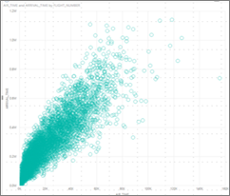

**Tip**

Too many data points on a visual can bog it down, so a sophisticated sampling algorithm is used to ensure the accuracy of the visualization.

### Slicers

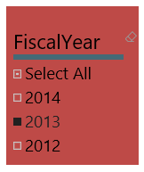

### Standalone images



### Tables

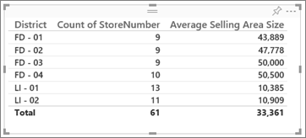

**Tip**

Work well with quantitative comparisons among items where there are many categories.

### Treemaps

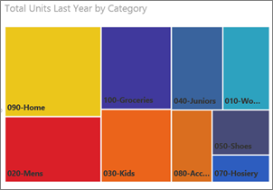

**Tip**

Are charts of colored rectangles, with size representing value. They can be hierarchical, with rectangles nested within the main rectangles.

### Waterfall charts

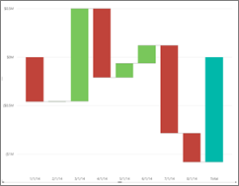

**Tip**

Waterfall charts show a running total as values are added or subtracted.